

Value Furniture

Graded unit project

Peter Hoben | HND Computing | July 2019

# Contents

Introduction to Project 2

Aims and Interpretation of the Brief 2

Initial Investigation 3

Fact Finding Techniques 3

Reading About the System 4

Observation 5

Interviews with Employees 7

Comparison of Techniques 16

Functional Requirements 17

Non Functional requirements 18

Initial Top Level Use Case Diagram 19

Initial Top level Class Diagram 20

Identification of resources and materials required 21

Development Platform 21

Programming Languages 22

C# 22

Java 22

Frameworks 23

Asp.net MVC 23

Language Justification 24

References 25

# Introduction to the Project

## Aims of the project & Interpretation

The project is to build from scratch a new IT system for Value Furniture, which will replace the existing paper-based system in operation. This will be a stock control system that also allows for orders to be placed, and a function that allows the Company to view a list of previous orders made by customers.

Value Furniture are a small wholesale furniture business who sell to retail outlets, they do not sell to the general public. All customers must have an account that is valid. At present the business is growing and they feel that they need a modern IT system to help increase productivity of the company and deal with the growing list of customers.

Currently the only information held on computer is company names and addresses, with all other information being in paper format. This can lead to many admin errors and a slow process of retrieving stock data.

A budget of £25,000 has been set aside by Value Furniture for this and the timescale has a deadline of 12st August 2019.

Given the project brief, it is my interpretation that the client is looking for an IT system which will be used in house by Staff.

The system will allow staff members to amend stock information and details, process a new customer order for a valid customer and also check a customer’s order history.

Customers at the moment currently order by supplying a Product ID number to the sales assistant in store, this is then added to the Order to create an orderLine. Now with the proposed system being online, this product ID will need to be unique for every product.

Customers will be able to view the stock online, with stock quantities and prices being available to them. Customers will still have to call Value Furniture or visit the premises to complete the order with a sales agent who will do this on the new system.

If the customer is in fact registered to use the online system, they will be able to create an order on line, which will result in a unique OrderId being produced. This OrderId can then be quoted to staff who will process the order for the customer.

Furthermore, the system should be able to provide live data regarding stock levels when an order is being made.

### ***Fact Finding Techniques***

In order to gain further information necessary to complete this project, I have had to go beyond the project brief. The project brief did not give me enough information about certain areas in order to move forward with the project. Fact finding has allowed me to look further into this and gain information related to the many different areas that will help to make up the final system.

* Business Rules- these were the policies and constraints of the organization. In particular this help defines what information different users of the system dealt with as part of their roles.
* To assist in developing requirements of the system, which will be important during the development.
* Helped to give me an understanding of how the system worked.
* This has also helped with costing the system, so that I can balance out the cost/benefits and see if the project is worth taking on board against the time required to complete.

To assist me in the Fact Finding I opted to follow the Fundamental Questions statement ( Graham Cadger PowerPoint) this helped me to think logically about the information I needed from Value Furniture.

The questioning rules were

1. Purpose: What is done?
2. Usefulness: Why is it done?
3. Means: How is it done?
4. Personnel: Who does it?
5. Location: Where is it done?
6. Time/Sequence: When is it done?

With these rules in mind for all research and questioning, this will lead me to ask the right questions and think correctly about how the system needs to operate.

## Reading about the system

One of the first tasks which I had to undertake, in order to gather an understanding of the project objective, was to research as much as possible about this organization. This meant that I had to find out more about what goes on ( in relation to information ) at a Whole sale supplier. Finding out what information is stored, how is it used, who uses the information and who can edit the information.

Documentation for the existing system was limited but looking over this helped to give a further insight into the current system in operation. The order form showed me the main information that needs to be stored in the database.

## Advantages

This gave me an excellent understanding of what Value Furniture do and gave me an idea in advance on how their IT should be designed. It also gave me the information that I needed in order to prepare for my Observation and Interviews to be conducted at a later date. This method of fact finding was appropriate for me, as I had no previous familiarity with how a Stock Control system may operate or be used.

## disadvantages

All the documentation that I have read may not actually reflect how in reality the system is currently operating at Value Furniture. Since the documentation could in fact be out of date, or processes may have changed whether formally or informally.

This was a time-consuming stage, as so much documentation is available and some parts of it may now be irrelevant but are still part of the Organizations Policy.

## Observation

I spent a week at Value Furniture, shadowing staff. I managed to spend time with at least one employee for every role that interacts with the system. This allowed me to see exactly what each role is responsible for on a day to day basis, and at what points they would interact with the IT system once it is operational. I also got firsthand experience of what information they would put into the system, as well as seeing what information needs to be extracted from customers and for what purpose.

The information gained by doing this helped to give me an idea of how many times on a daily basis the system would be interacted with and seeing why the information was needed first hand will help in the development process.

## Advantages

Using this fact-finding technique gave me a good overview of how the staff operate on a daily basis in each of their roles. This highlighted the pressure that the staff work under, and how an improved Stock Control System could help to reduce these pressures.

## disadvantages

Observation can lead to a few negative issues. At times staff didn’t like to be observed doing their roles and this was noticeable. With this in mind I may not have been seeing fully how the role operates as normal but was in fact seeing how the role operates “by the book”.

This was also very time consuming, having spent a week onsite.

## Interview Questions

At least one member of staff for each role was selected to be interviewed. Each person did agree to do this voluntarily. What I done was make sure that these were planned well in advance and at a suitable time for each employee.

Interviews were conducted with a fixed set of questions pre planned, where if necessary further points could be added to the question dependent on the answer. If the answer given required further probing questions.

## Advantages

The advantage of this is that it allowed me to adapt my questioning if an answer given led to me needing more information. This also allowed me to probe deeper with the questions to get a greater degree of detail regarding the subject from the interviewee. Interviews are seen as being far more personal and therefore the interviewee is more likely to give honest answers rather than standard responses.

## disadvantages

This was a costly exercise and very time consuming, from both the time to conduct the interviews and also having to go back over each interview recording and analyze the answers, and to document them. I did notice that from my interviews with the staff, staff seemed to give different answers to the same question which does present some conflicting information that I will need to look at later to try and resolve.

## Completed Interview Questions

(1) What are the main features that the system should be able to perform?

|  |
| --- |
| The Value furniture IT system is required to provide to:   * Allow staff to   + Add new customers   + Add new furniture   + Show increase/decrease of stock levels on a product and have this displayed on screen.   + Add new orders to the system   + View orders placed by specific customers   + View invoices attached to specific customers   We also require a website that will allow customers to:   * Track an order * Place an order * Make a Payment * Cancel an Order * Generate Returns Slip |

(2) What kind of products does Value Furniture sell (For Example: Chairs, Tables, Beds etc.)

|  |
| --- |
| All of the above |

(3) How many products does Value Furniture sell?

|  |
| --- |
| In the region of 250 |

(4) What is the deadline for the project to be completed?

|  |
| --- |
| 9th June 2017 |

(5) What is the budget for this project?

|  |
| --- |
| £25000 |

**Making an Order**

(1) How does a customer place an order?

|  |
| --- |
| **In Store**   * The Product Id will be entered by the Sales Assistant which will retrieve the product details. * Once an order has been completed and paid for the stock details will be adjusted automatically. * When a customer is making a purchase, we will record their details, these details will be entered onto the computer   **Online**   * The customer will select their products and enter quantities required. * They will then submit their order and at this point will be required to submit their email address and password as part of the customer verification process. * When the customer submits their order via the website, the stock figure will be adjusted automatically.   If a customer has not registered previously then they will have to prior to placing their order:   * enter their details (Name, address, telephone number) and submit these details along with their email address and their chosen password. * they will then receive a confirmation email asking them to click on a link to activate their account, once this has been done they can then submit their order.   The following details are required to be provided:   * Customer Id, * Name, * Address, * Telephone number (home & mobile), * email address |

(2) What is the policy for if a customer is buying a bulk order of a product but not enough are in stock?

|  |
| --- |
| We will advise of an alternative if out of stock and also when the requested item will be back in stock. |

(3) For the order details, what details do you wish to be recorded?

|  |
| --- |
| * Order Id * Customer Id, * Product Id, * Product Description, Product Colour (if appropriate/required), Product Price – these details should all be read from the database. * Quantity ordered * Delivery date & instructions |

(4) Will the order details still be sent to the customer by post?

|  |
| --- |
| No, all confirmations are sent by email. |

**Customer Registration**

(1) What happens if the customer is a new customer?

|  |
| --- |
| If a customer has not registered previously then they will have to prior to placing their order:   * enter their details (Name, address, telephone number) and submit these details along with their email address and their chosen password. * they will then receive a confirmation email asking them to click on a link to activate their account, once this has been done they can then submit their order |

(2) What information is needed to register a new customer?

|  |
| --- |
| The following details are required to be provided:   * Customer Id, * Name, * Address, * Telephone number (home & mobile), * email address |

(3) Does a customer need an account to place an order?

|  |
| --- |
| Customer account is created by staff before placing an order. |

(4) The project brief states that discounts can be applied on the manager’s discretion, what conditions have to be meet to be eligible for a discount?

|  |
| --- |
| £25000 |

(5) If an order is being discounted, what is the discount rate(s)?

|  |
| --- |
| This varies depending on customer purchase history and the item value. |

(6) How does a customer log into their account?

|  |
| --- |
| If a customer has not registered previously then they will have to prior to placing their order:   * enter their details (Name, address, telephone number) and submit these details along with their email address and their chosen password. * they will then receive a confirmation email asking them to click on a link to activate their account, once this has been done they can then submit their order |

(7) If a customer can access their account then what information can they see? For example: Previous Orders, Change Address etc.

|  |
| --- |
| Their personal details and all previous orders in last 18 months. |

**Cancelling an Order**

(1) What is the policy for cancelations?

|  |
| --- |
| Orders can be cancelled up to 48 hours after order placement.  When a customer cancels an order we check the delivery date, if it is less than 48 hours  before the delivery date there is a 25% cancellation fee. Orders can be cancelled up to 48  hours after order placement. All details regarding a cancelled order require to be deleted  from the system.  Customers can cancel orders over the phone or by calling into the store. |

**Amending Orders**

1. Are customers, after placing an order, able to amend it?
2. If so, then how long do customers have before they can no longer amend orders?

|  |
| --- |
| Orders can be amended up to 48 hours after order placement. If it is less than 48 hours prior to the delivery date, there will be a 10% charge. |

(3) In what ways are customers able to amend orders?

|  |
| --- |
| Online and by phone. |

**Returning Items**

(1) What is the procedure for returning items?

|  |
| --- |
| Yes, the customer can return items within 28 days of purchase.  This can be done online, by accessing their order and printing out a returns label and mailing the item to us or alternatively by bringing the item(s) into the store.  We require that the following details are recorded for each item returned:   * Order Id * Item Code * Date of Return * Reason for return * Condition of item * Customer No * Customer contact details |

**Delivery Options**

(1) What is the average delivery time for an order?

|  |
| --- |
| This is dependent on the item ordered |

**Tracking an Order**

(1) How does a customer track orders?

|  |
| --- |
| They will log in and be able to see all their orders (past & current) or they can use the tracking number that will be provided in the email confirmation of their order. |

**Payment Processing/Invoicing**

(1) When does the customer pay for the order?

|  |
| --- |
| At the time of order placement. |

(2) What payment options are available for the customer?

|  |
| --- |
| Acceptable payment methods are – cash, credit/debit cards, PayPal & invoices for corporate customers. |

**Stock Control**

1. Does the system alert staff if there is low stock?
2. Are items that have low stock automatically re-ordered?

|  |
| --- |
| Currently the Manager identifies what is required by walking round the store room.  Items are ordered when they are required, that is, when the stock runs low. We do not currently have a stock figure which we use to determine when to re-order, it is done on judgment of the Manager.  We wish to identify a stock level for each item that will automatically trigger a request for an order to be generated.  We do not currently have a stock figure which we use to determine when to re-order, it is done on judgment of the Manager.  We wish to identify a stock level for each item that will automatically trigger a request for an order to be generated. |

(3) When new stock arrives/leaves, who will be the one who adds it to the system?

|  |
| --- |
| Store Manager |

(4) As there will be no need for a second log, what will the office clerk do during the arrival/checking of stock?

|  |
| --- |
| They are responsible for dealing with customers. |

(5) How often does the stock get checked to verify that the number in system is accurate to number in stock?

|  |
| --- |
| Always on arrival into the warehouse. |

**Report Generation**

(1) Who is in charge of generating the invoice and sending them to customers?

|  |
| --- |
| Invoices are emailed to business customers on a monthly basis, this is to be generated automatically and sent electronically. |

(1) Who has access to the system? (Admin Privileges)

|  |
| --- |
| **Sales Assistant** – responsible for processing customer orders, entering of orders, taking payment  **Invoices Clerk** – responsible for sending out invoices to customers and for the processing of payments linked to these orders.  **Store Foreman** - responsible for stock control  **Stores Assistants** – responsible for the dispatch of goods to customers.  **Shop Manager** – has access to all areas of the database and has sole responsibility for modification of prices.  As we are a small company (8 employees), it is necessary that people are able and willing to do the work of other job roles. The Sales Assistants & Invoices Clerk will be able to do the work of each other.  All users will require a user id and password to log in. |

(2) What accessibility options are needed for the system?

|  |
| --- |
| The website will have to conform to the Equality Act 2010. We await your recommendations as the IT expert. |

1. What are the minimum hardware requirements for the system?
2. What are the security requirements for the system?

|  |
| --- |
| We await your recommendations as the IT expert, |

(5) How often is the system’s data backed up?

|  |
| --- |
| We await your recommendations as the IT expert on suitable backup procedures. |

(6) Is there additional information about the customer that will be stored by the system that is not stated in the brief?

|  |
| --- |
| No |

(7) Is there additional information about individual items that the system stores that is outwith the project brief?

|  |
| --- |
| The following date is held about products:   * Product Id, * Product Description & Colour, * Product Price, * Quantity on hand, * Reorder quantity, * Reorder level, * Quantity on order with delivery dates * Supplier Id |

(8) Is there anything, that is not mentioned in the project brief, that the system

has to allow staff to do?

|  |
| --- |
| The following reports are required:  **Stock Item/Stock Levels Report**:   * Product Id, * Product Description, * Product Colour (if appropriate/required), * Product Price, * Quantity on hand * Re-order quantity * Delivery lead times * Supplier Id   **Stock by Supplier Report**:   * Supplier Id, then grouped by Product Id showing: * Product Description, * Product Colour (if appropriate/required), * Product Price, * Quantity on hand * Re-order quantity * Delivery lead times   **Invoices Report**:   * Invoice No * Date of Invoice * Invoice Amount * Customer Id * Overall totals by customer/invoice   **Customer & Orders**:   * Order No * Date of Invoice * Order Amount * Customer Id * Overall totals by customer/order   All reports should be able to be viewed on screen, with the option to print and also be able to be exported into Ms Excel. |

## Comparison of techniques

Each type of fact-finding technique had their own advantages and disadvantage. Each though provided a different insight into how the actual system currently operates. Some contradictions were noticed.

Similarly, when interviewing employee’s, sometimes the answers seemed staged. As if they were answering what they thought I wanted to hear rather than answering it as honestly as they could.

Each had its own strengths and weaknesses, all were time consuming.

In order to get the best possible insight into how a system works, no one process of fact finding seems to be ideal on its own, they all work together to help build a complete picture of the system in practice.

## Functional Requirements

* A main login Page
* Ability to add staff logins
* Ability to add a new customer to the system
* Add/Decrease the stock levels of a product
* Display Current Stock Levels
* Allow a new order to be added to the system
* Allow all orders placed by a customer to be added to system
* Display all completed invoices
* Have a secure login system for staff consisting of username/password
* Each user group should have access to their own set of actions
* Information about customers needs to be stored
* Facility to track an orders progress
* Payment Facilities online
* Allow an order to be cancelled
* System to allow for order returns
* System needs to be large enough to store at least 250 products
* Facility to email an invoice to a customer
* Sales assistants and Invoices clerks should share similar access
* System should generate reports for Stock
* System should generate reports for Invoices
* System should generate reports for Customer Orders
* If sales value is over £25,000 there must be an option for adding a discount

## Non-Functional Requirements

* A responsive design
* Must comply with necessary legislation
* The design must be branded accordingly
* Accessible from Desktop Pc’s, Tablets, Mobile Devices
* Completed Within budget of £25000

## Top Level Use Case Model

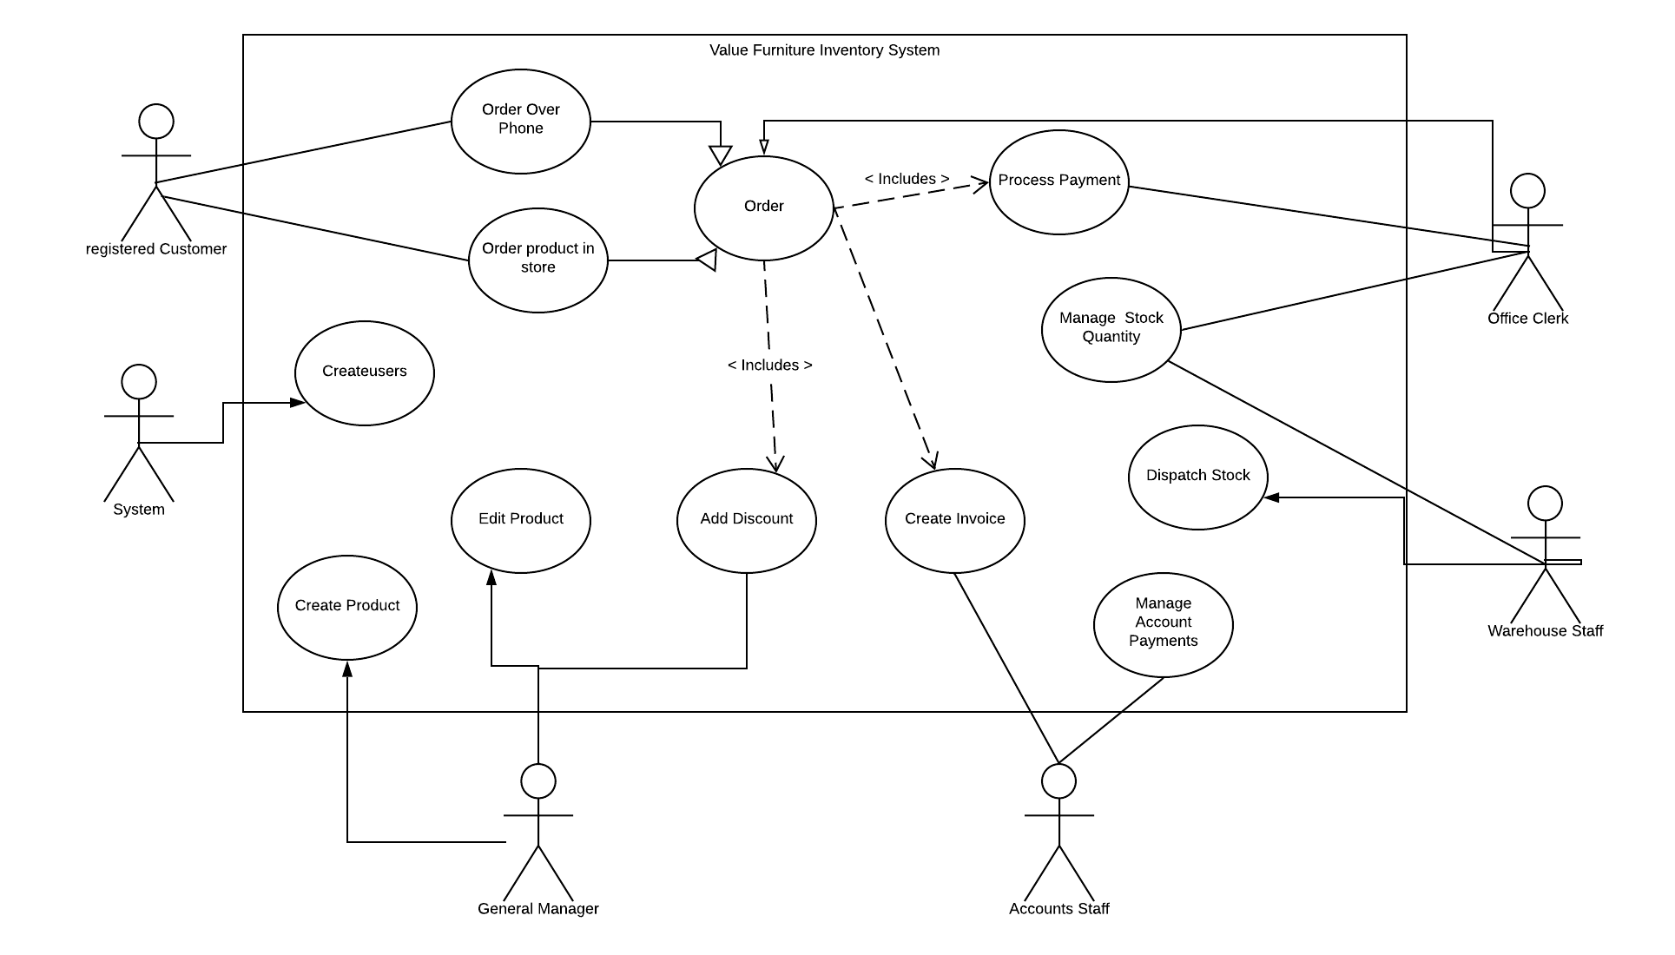

## Initial Top Level Class Diagram

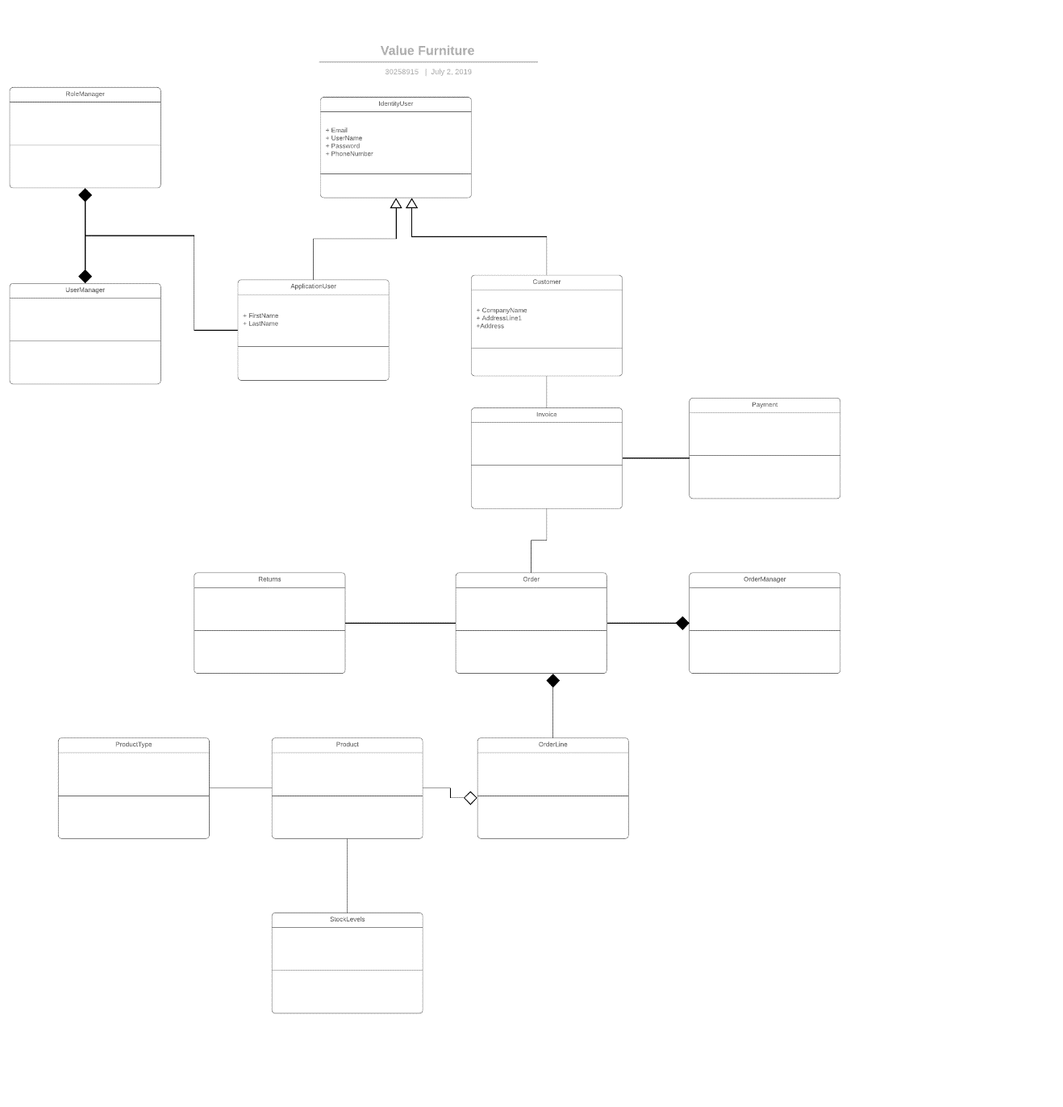

## Identification of resources and materials required

## development platform

Visual Studio IDE, using the .Net framework has been selected for the development of code for the system. This will be coded using c#.

Visual Studio is a high-level object-oriented environment for the Windows platform. It is ideal for developing websites, web apps and web services. This will allow the use of Windows API’s and Windows Forms to be used in the project. Visual Studio has a massive range of libraries available including MVC model view controller, which will play a major role in this development.

Visual Studio includes many components and extensions that will be used to complete this project. It also benefits from built in tools to aid in creating the GUI and the database which will be used within the system.

Testing of the application will be done by using the inbuilt features of Visual Studios unit testing.

No extra hardware requirements have been identified during planning for this project. I have assessed the needs of the project and can see that this can be set up to run on desktop pcs, tablets, laptops or mobile phones. For example, if it was a game being written, Extra Hardware, perhaps a joystick or controller would be needed.

GitHub will be used with the extension included in Visual Studio for matters relating to code management and Version control. This is vital to the success of the project as it will ensure productivity is efficient.

SQL Database has been selected to hold all the information, again this uses an sql server that is built into Visual Studios IDE.

UML diagrams have been created using Visual Paradigm.

Microsoft Word has been used to create all the documentation to support the project.

## C# Programming language

C#

C# is one of the most popular development languages currently in use. This was Developed by Microsoft, and in turn this led to the creation of the .NET framework. C# is based on the principles of Object-Oriented Programming.

C# is modern and a general-purpose language, that is easy to learn and can produce efficient programs. These programs can also be complied to run on many various computer platforms. It has become so common mainly due to the fact that it is integrated so well with Windows.

This language is used so much that a knowledge of c# is in such high demand within the industry and Educational Facilities. C# is fairly similar to Java which makes it an easy transition from java to c#.

## Java

With Java it has many advantages over other languages as it is suitable for almost any task a developer may encounter. Java itself is one of the easiest programming languages to learn, with Java it is also possible to create much reusable code, alongside modular programs. This comes from its creation for the Object Oriented Programming market. One of the biggest advantages that Java has is that a program written with Java can be reused on literally any system. This is due to the java platform being independent.

The main disadvantage of using Java, is that Java is heavy on memory-consumption when compared against many other languages such as C#.

This is because the main requirement of a Java App is that it has to be run on a virtual machine.

## 

## Frameworks ASP.NET MVC

This is a software Framework designed specifically to help in the development of Web Based Applications. With ASP.NET MVC the user has access to a vast range of libraries that will allow the user to create complicated web based applications. These libraries allow the user the easy access to manipulate the program, this could be for example accessing databases or even templates to use for design. ASP.NET is an open sourced environment which is increasing in popularity.

MVC stands for Model View Controller.

The model defines any business logic that is required. This part will handle any communication that is made between a user Interface and the underlying Database. In effect it will detail how a task is to be carried out. With MVC it makes use of POCO classes (Plain Old CLR objects ).

Displaying all this information to a User is handled from the View part. With the output more commonly being a web browser, the data from the view is sent as HTML code. Typically, a view would not contain any of the Code, it would only be HTML, but with the introduction of RAZOR pages, these in themselves allow c# code to be placed within the View element. This is done using server side coding.

The Controller then will be the link that exists from the Model to the View. A controller will process all the code with the Model and then send this to a view to be displayed. A controller tends to be another class that will contain specific methods for that controller. Methods that are relevant to the View and the Model that it is incorporating.

It can be seen then, that using ASP.NET and MVC framework that it makes developing a web application quite efficiently. Since smartphone technology has taken off so quickly in recent years, MVC’s ability to incorporate responsive pages ( such as using bootstrap ) makes it an ideal choice for developers for coding.

## justification of platform language

## choice of language

C# has been selected as the language of choice for this project because it is a modern object-oriented programming language. C# works on the Microsoft platform with the .Net framework. C# is strong at building Windows desktop applications and is also now used to build web applications. Using cross platform tools such as Xamarin it can also be used to develop Mobile Apps, if this project requires an app to be created in the future, then the structure will be in place for it.

C# is also the 4th most popular programming language. I have elected to use this as I have the most experience in this programming language, whilst Visual Studio provides so many libraries that can be referenced to help build the solution.

Also with this language being so popular, there are many online resources that are available to me for assistance, a good example is stack overflow and also Microsoft own online documentation.

Visual Studio using c# for code and MVC as the development model for the project has been selected. I have chosen this due to its flexibility and wide range of support online. This is the platform which I have the most experience with. This choice was helped by the vast array of online resources that are on hand to help me.

Choosing this will ensure a feature rich, efficient web application is built for Value Furniture.

## References and additional information

#### Interview questions and answers

#### Fact_finding_techniques powerpoint presentation by Graham Cadger

#### Fact finding <http://www.cse.dmu.ac.uk/UMLISAD/chapter5/1_5_2.html>

#### <https://www.educba.com/c-sharp-vs-java-performance/>

1. *Software Project Survival Guide by Steve McConnell*
2. *Applying UML and Patterns by Craig Larman*
3. [*www.howdens.com*](http://www.howdens.com)